FINAL

November 2023

Gender pay gap narrows for FTSE 100 board directors but progress remains slow – average pay for women £309k vs. £1.04m for men

- Average pay gap shrunk from 74% in 2021 to 70% in 2022
- Only 9% of female board roles are the higher paid and typically more influential executive roles
- 91% of female board roles are non-executive

The gender pay gap for FTSE 100 board directors narrowed in 2022 but still remains markedly high, with the average pay for women directors (£309,000) 70% less than the average pay for male board directors (£1.04m), shows new research by Fox & Partners, the employment and partnership law specialists.

The FTSE 100 gender pay gap narrowed in the last year from 74% as pay for women directors went up at a faster rate than men last year. Average female board director pay increased by 26% in 2022 to £308,984 from £245,525 in 2021. Average male director pay increased by 11% to £1.04m in 2022 from £935,235 in 2021.

However, Catriona Watt, Partner at Fox & Partners explains that the pay gap remains very high, in part because the vast majority of women board directors are in typically lower paid non-executive roles.

91% of the 426 female directors at FTSE 100 companies were in a non-executive role which typically carries less day-to-day authority. Women executive directors were paid on average more than 20 times (£2.4m) the average amount paid to female non-executive directors (£118,738). The average pay of male executive directors (£3.3m) was more than 18 times the average pay of male non-executives (£179,892).

Men are still paid significantly more than women both for executive and non-executive roles. On average, male non-executives (£179,892) were paid 52% more than females (£118,738) -- that is partly because they tend to have a higher share of more senior non-exec roles such as “Chairman”. Male executives (£3.3m) were paid 38% more than female executives (£2.4m).

Catriona Watt says; “While the latest data shows improvement, there still remains a yawning gap in director pay between the genders.”

“For significant change to occur, business will need to continue investing in programmes that prepare women for the most senior executive positions, for example by ensuring that they have access to projects that bolster their experience and address any potential gaps, as well as being transparent about requirements for promotions and progression .”

“Companies should really think about the culture they want to foster from a diversity and inclusion perspective, ensure messages in support of that culture come from the top and review internal policies – including family and flexible working related policies – to ensure they support the culture the company is striving to achieve.”

“Examining available data as to gender disparity in businesses including when and why there is a decline in women in leadership positions is also an important starting point for identifying potential systemic issues.”

“Companies could also provide women with more informal and formal networking, mentoring and championing opportunities and more regularly review how work is allocated to support their progression up to the highest positions in the firm.”

“The appointment of a board member whose responsibility is to advance women’s opportunities within the organisation can help to make this a priority issue and fully identify and address any barriers to progression and ways of addressing these.”

“Targets for all senior leaders to promote female opportunities can help to incentivise true and long-lasting change and help women succeed in the very highest positions of the firm.”

Average pay of male and female executive and non-executive directors at FTSE 100 firms in 2022
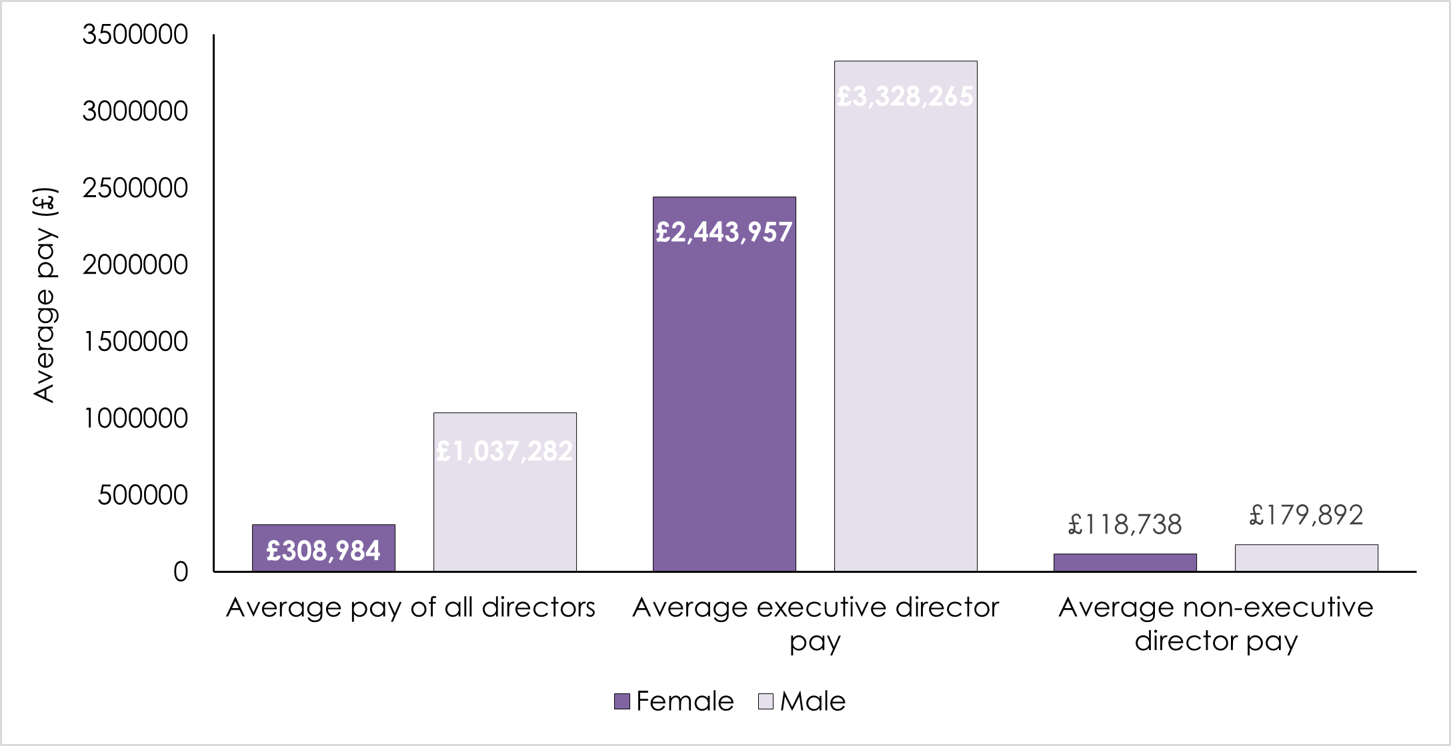
ENDS

Press Contact
Catriona Watt
Partner
Fox & Partners
D: +44 20 7618 2887
M: +44 7912 731 883

